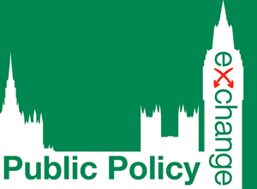 | 6th Annual International Symposium on  Preventing Human Trafficking  1st December 2015

Delegate Fees
 | National Governmental Organisations,  Executive Agencies, Legal Sector, Private Sector | Local and Regional Authorities, Universities  and Colleges, Trade Unions, Think Tanks
1 Place | €395 / £345 per delegate | €345 / £295 per delegate
2+ Places | €345 / £295 per delegate | €310 / £265 per delegate

Delegate Details
Delegate Name | Position | Email Address
1.
2.
3.

Key Contact Details Invoice Details
Name:  Organisation:  Department:  Address:  Telephone:  Email:  Invoice details are the same as Key Contact Details | Name:  Organisation:  Department:  Address:  Telephone:  Email:  Purchase Order No. (if applicable):

Method of Payment
NOTE: UK registrations are subject to VAT which is charged at 20%
I will pay €/£ by credit card. Please contact me to obtain the necessary details
Please invoice my organisation for €/£
I enclose a cheque for €/£ payable to Public Policy Exchange Ltd

Confirmation
I/We agree to notify you of all cancellations and changes in writing no less than 30 days prior to the date of the event. I/We further agree to pay €120/£100 administration charge per place on cancellation. If cancellation is received less than 30 days prior to the date of the conference then the full fee is payable; however, a substitute may be sent.
Signed:
Date:

PLEASE EMAIL BACK TO bookings@publicpolicyexchange.co.uk

